**PATTERN QUESTIONS**

|  |  |  |  |  |
| --- | --- | --- | --- | --- |
| SI. No. | Pattern | Article | GfG | Solution |
|  | 1 |  | [Link](https://takeuforward.org/pattern/pattern-1-rectangular-star-pattern/) | [Link](https://practice.geeksforgeeks.org/problems/square-pattern/1?utm_source=youtube&utm_medium=collab_striver_ytdescription&utm_campaign=pattern_1) | [Link](https://youtu.be/tNm_NNSB3_w?t=91) |
|  | 2 |  | [Link](https://takeuforward.org/pattern/pattern-2-right-angled-triangle-pattern/) | [Link](https://practice.geeksforgeeks.org/problems/right-triangle/1?utm_source=youtube&utm_medium=collab_striver_ytdescription&utm_campaign=pattern_2) | [Link](https://youtu.be/tNm_NNSB3_w?t=856) |
|  | 3 |  | [Link](https://takeuforward.org/pattern/pattern-3-right-angled-number-pyramid/) | [Link](https://practice.geeksforgeeks.org/problems/triangle-number/1?utm_source=youtube&utm_medium=collab_striver_ytdescription&utm_campaign=pattern_3) | [Link](https://youtu.be/tNm_NNSB3_w?t=1054) |
|  | 4 |  | [Link](https://takeuforward.org/pattern/pattern-4-right-angled-number-pyramid-ii/) | [Link](https://practice.geeksforgeeks.org/problems/triangle-number-1661428795/1?utm_source=youtube&utm_medium=collab_striver_ytdescription&utm_campaign=pattern_4) | [Link](https://youtu.be/tNm_NNSB3_w?t=1198) |
|  | 5 |  | [Link](https://takeuforward.org/pattern/pattern-5-inverted-right-pyramid/) | [Link](https://practice.geeksforgeeks.org/problems/triangle-pattern/1?utm_source=youtube&utm_medium=collab_striver_ytdescription&utm_campaign=pattern_5) | [Link](https://youtu.be/tNm_NNSB3_w?t=1261) |
|  | 6 |  | [Link](https://takeuforward.org/pattern/pattern-6-inverted-numbered-right-pyramid/) | [Link](https://practice.geeksforgeeks.org/problems/triangle-number-1661489840/1?utm_source=youtube&utm_medium=collab_striver_ytdescription&utm_campaign=pattern_6) | [Link](https://youtu.be/tNm_NNSB3_w?t=1419) |
|  | 7 |  | [Link](https://takeuforward.org/pattern/pattern-7-star-pyramid/) | [Link](https://practice.geeksforgeeks.org/problems/triangle-pattern-1661492263/1?utm_source=youtube&utm_medium=collab_striver_ytdescription&utm_campaign=pattern_7) | [Link](https://youtu.be/tNm_NNSB3_w?t=1473) |
|  | 8 |  | [Link](https://takeuforward.org/pattern/pattern-8-inverted-star-pyramid/) | [Link](https://practice.geeksforgeeks.org/problems/triangle-pattern-1661493231/1?utm_source=youtube&utm_medium=collab_striver_ytdescription&utm_campaign=pattern_8) | [Link](https://youtu.be/tNm_NNSB3_w?t=1870) |
|  | 9 |  | [Link](https://takeuforward.org/pattern/pattern-9-diamond-star-pattern/) | [Link](https://practice.geeksforgeeks.org/problems/pattern/1?utm_source=youtube&utm_medium=collab_striver_ytdescription&utm_campaign=pattern_9) | [Link](https://youtu.be/tNm_NNSB3_w?t=2056) |
|  | 10 |  | [Link](https://takeuforward.org/pattern/pattern-10-half-diamond-star-pattern/) | [Link](https://practice.geeksforgeeks.org/problems/triangle-pattern-1661718013/1?utm_source=youtube&utm_medium=collab_striver_ytdescription&utm_campaign=pattern_10) | [Link](https://youtu.be/tNm_NNSB3_w?t=2112) |
|  | 11 |  | [Link](https://takeuforward.org/pattern/pattern-11-binary-number-triangle-pattern/) | [Link](https://practice.geeksforgeeks.org/problems/triangle-pattern-1661718455/1?utm_source=youtube&utm_medium=collab_striver_ytdescription&utm_campaign=pattern_11) | [Link](https://youtu.be/tNm_NNSB3_w?t=2362) |
|  | 12 |  | [Link](https://takeuforward.org/pattern/pattern-12-number-crown-pattern/) | [Link](https://practice.geeksforgeeks.org/problems/double-triangle-pattern-1662664259/1?utm_source=youtube&utm_medium=collab_striver_ytdescription&utm_campaign=pattern_12) | [Link](https://youtu.be/tNm_NNSB3_w?t=2535) |
|  | 13 |  | [Link](https://takeuforward.org/pattern/pattern-13-increasing-number-triangle-pattern/) | [Link](https://practice.geeksforgeeks.org/problems/triangle-pattern-1661718712/1?utm_source=youtube&utm_medium=collab_striver_ytdescription&utm_campaign=pattern_13) | [Link](https://youtu.be/tNm_NNSB3_w?t=2812) |
|  | 14 |  | [Link](https://takeuforward.org/pattern/pattern-14-increasing-letter-triangle-pattern/) | [Link](https://practice.geeksforgeeks.org/problems/triangle-pattern-1662284916/1?utm_source=youtube&utm_medium=collab_striver_ytdescription&utm_campaign=pattern_14) | [Link](https://youtu.be/tNm_NNSB3_w?t=2922) |
|  | 15 |  | [Link](https://takeuforward.org/pattern/pattern-15-reverse-letter-triangle-pattern/) | [Link](https://practice.geeksforgeeks.org/problems/triangle-pattern-1662285196/1?utm_source=youtube&utm_medium=collab_striver_ytdescription&utm_campaign=pattern_15) | [Link](https://youtu.be/tNm_NNSB3_w?t=3057) |
|  | 16 |  | [Link](https://takeuforward.org/pattern/pattern-16-alpha-ramp-pattern/) | [Link](https://practice.geeksforgeeks.org/problems/triangle-pattern-1662285334/1?utm_source=youtube&utm_medium=collab_striver_ytdescription&utm_campaign=pattern_16) | [Link](https://youtu.be/tNm_NNSB3_w?t=3183) |
|  | 17 |  | [Link](https://takeuforward.org/pattern/pattern-17-alpha-hill-pattern/) | [Link](https://practice.geeksforgeeks.org/problems/triangle-pattern-1662285911/1/?utm_source=youtube&utm_medium=collab_striver_ytdescription&utm_campaign=pattern_17) | [Link](https://youtu.be/tNm_NNSB3_w?t=3282) |
|  | 18 |  | [Link](https://takeuforward.org/pattern/pattern-18-alpha-triangle-pattern/) | [Link](https://practice.geeksforgeeks.org/problems/triangle-pattern-1662286302/1?utm_source=youtube&utm_medium=collab_striver_ytdescription&utm_campaign=pattern_18) | [Link](https://youtu.be/tNm_NNSB3_w?t=3585) |
|  | 19 |  | [Link](https://takeuforward.org/pattern/pattern-19-symmetric-void-pattern/) | [Link](https://practice.geeksforgeeks.org/problems/double-triangle-pattern/1/?utm_source=youtube&utm_medium=collab_striver_ytdescription&utm_campaign=pattern_19) | [Link](https://youtu.be/tNm_NNSB3_w?t=3688) |
|  | 20 |  | [Link](https://takeuforward.org/pattern/pattern-20-symmetric-butterfly-pattern/) | [Link](https://practice.geeksforgeeks.org/problems/double-triangle-pattern-1662287416/1?utm_source=youtube&utm_medium=collab_striver_ytdescription&utm_campaign=pattern_20) | [Link](https://youtu.be/tNm_NNSB3_w?t=3996) |
|  | 21 |  | [Link](https://takeuforward.org/pattern/pattern-21-hollow-rectangle-pattern/) | [Link](https://practice.geeksforgeeks.org/problems/square-pattern-1662287714/1?utm_source=youtube&utm_medium=collab_striver_ytdescription&utm_campaign=pattern_21) | [Link](https://youtu.be/tNm_NNSB3_w?t=4349) |
|  | 22 |  | [Link](https://takeuforward.org/pattern/pattern-22-the-number-pattern/) | [Link](https://practice.geeksforgeeks.org/problems/square-pattern-1662666141/1?utm_source=youtube&utm_medium=collab_striver_ytdescription&utm_campaign=pattern_22) | [Link](https://youtu.be/tNm_NNSB3_w?t=4541) |

**PATTERN 18**

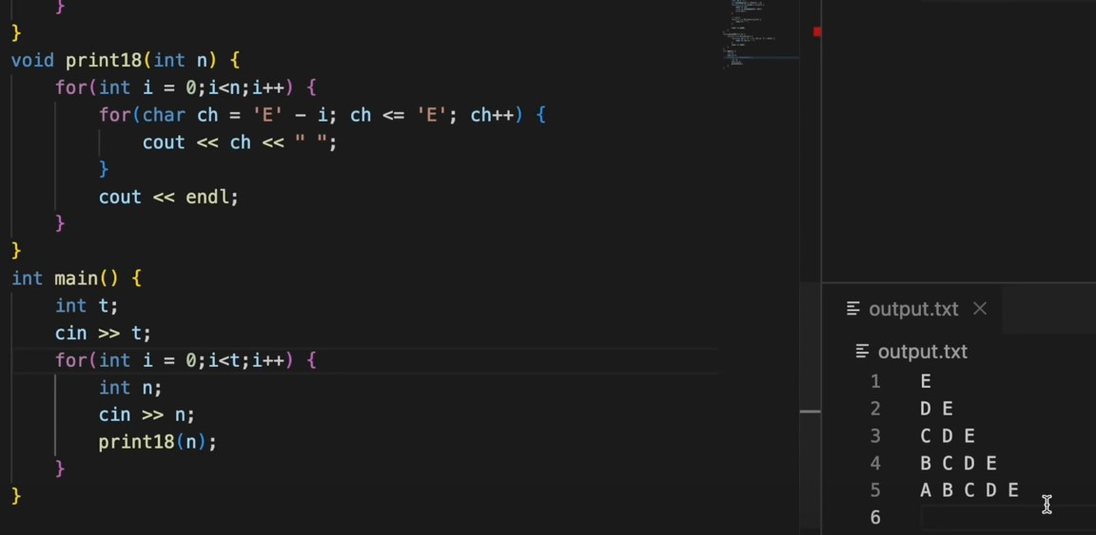

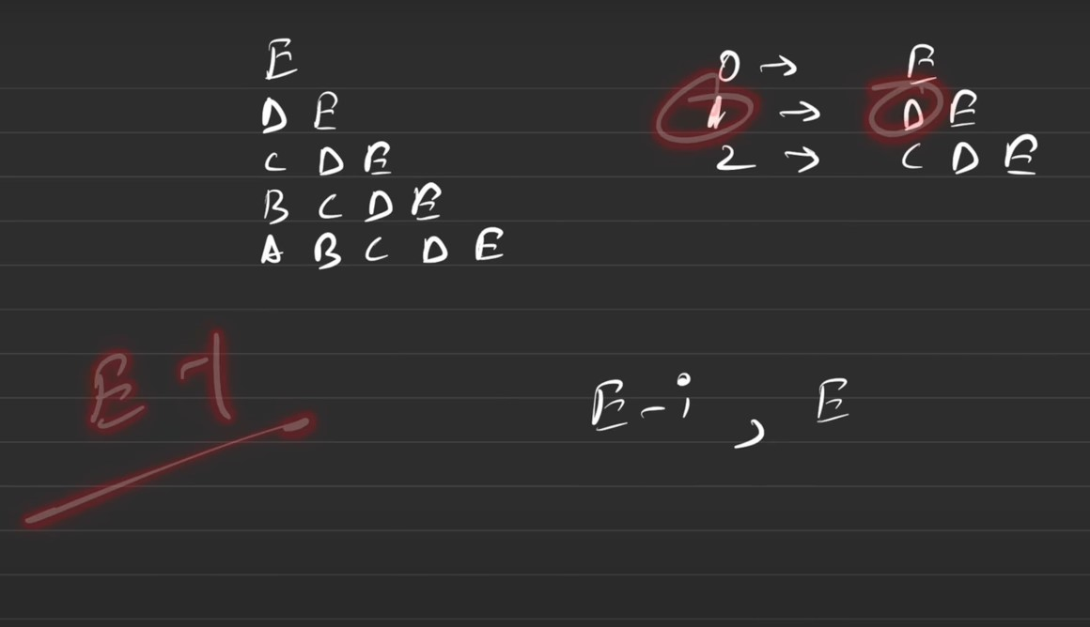

**PATTERN 19**

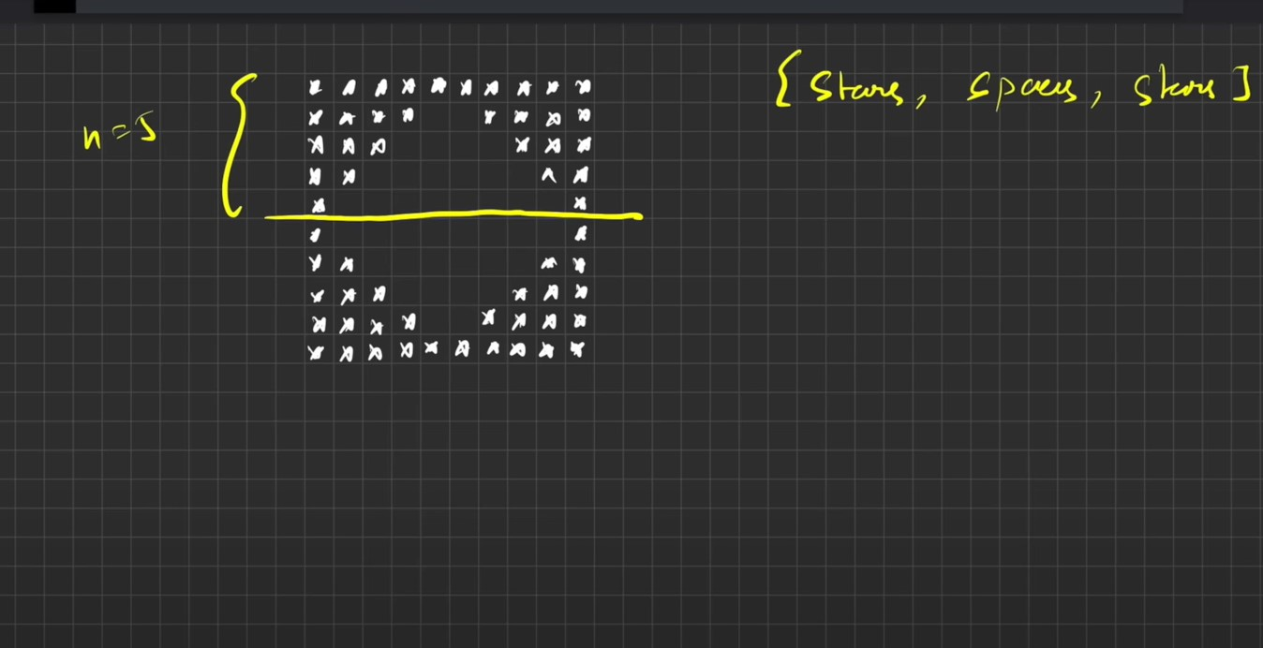

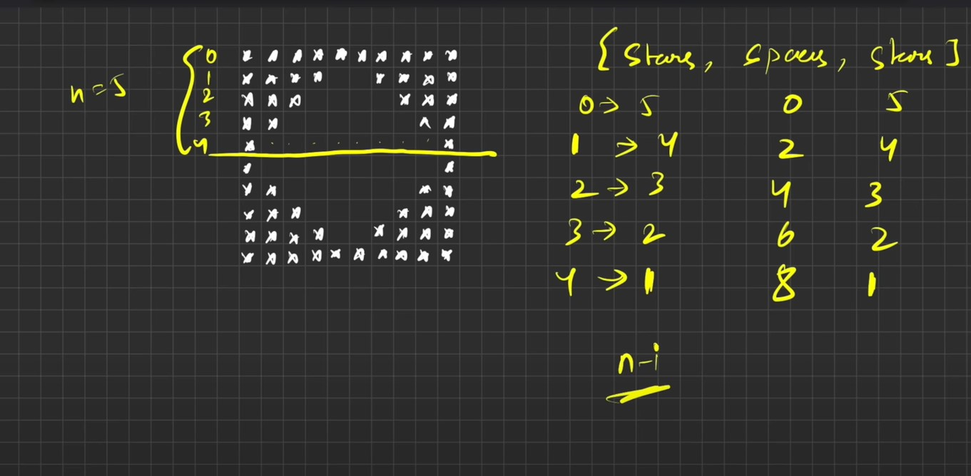

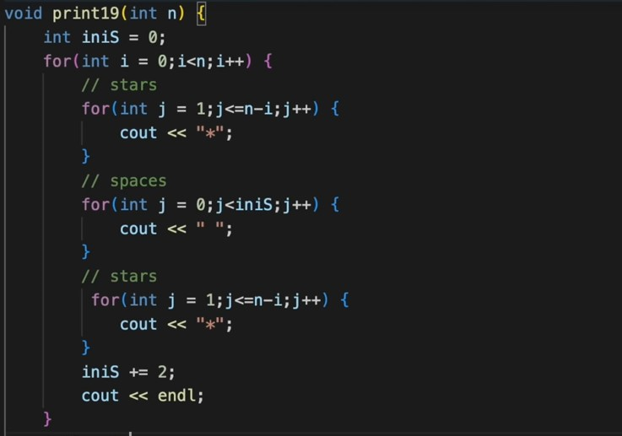

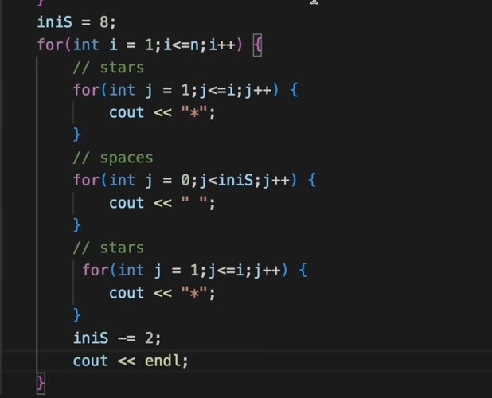

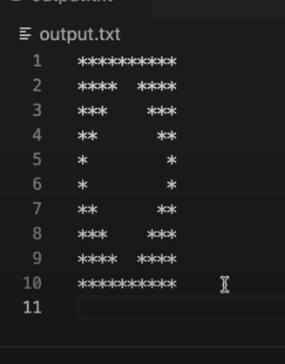

**PATTERN 20**

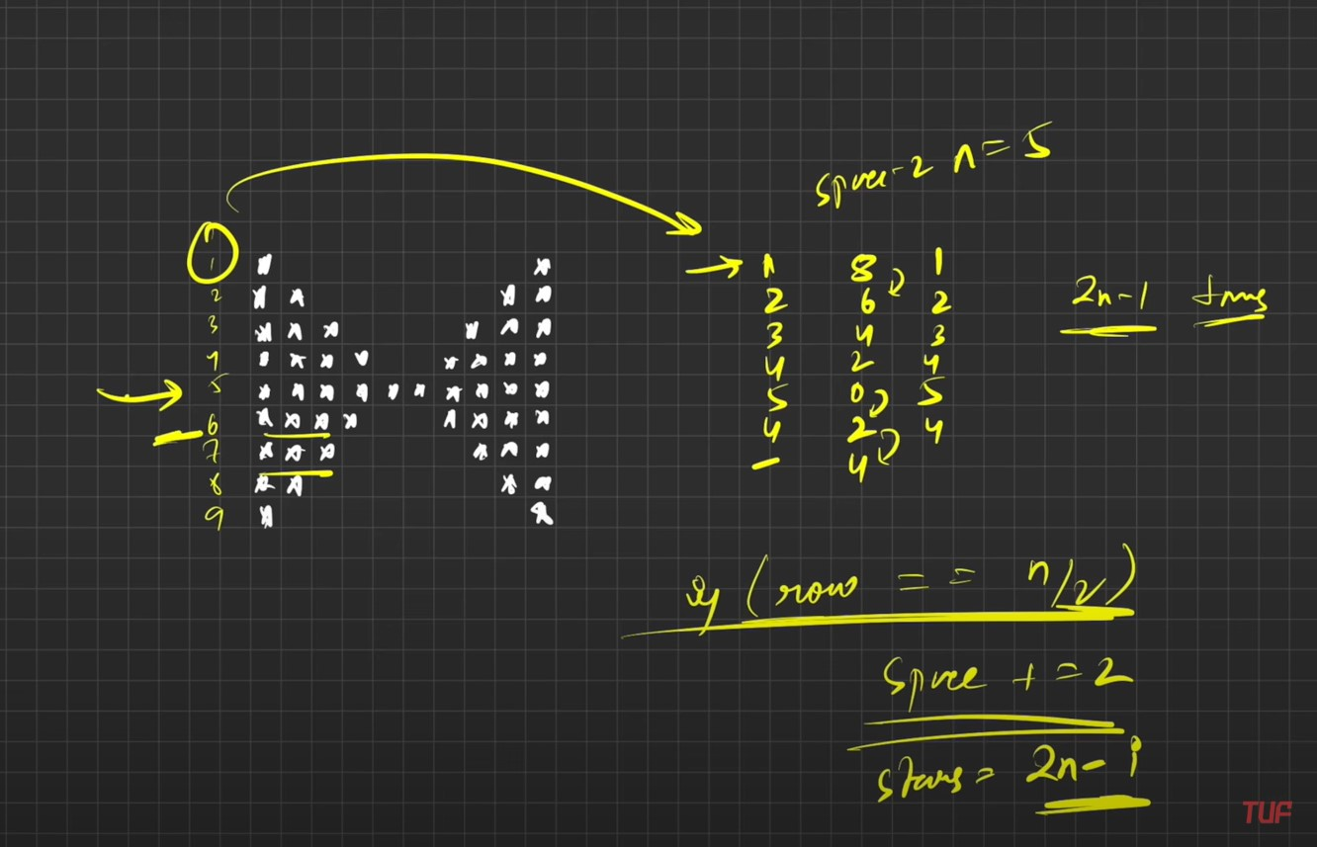

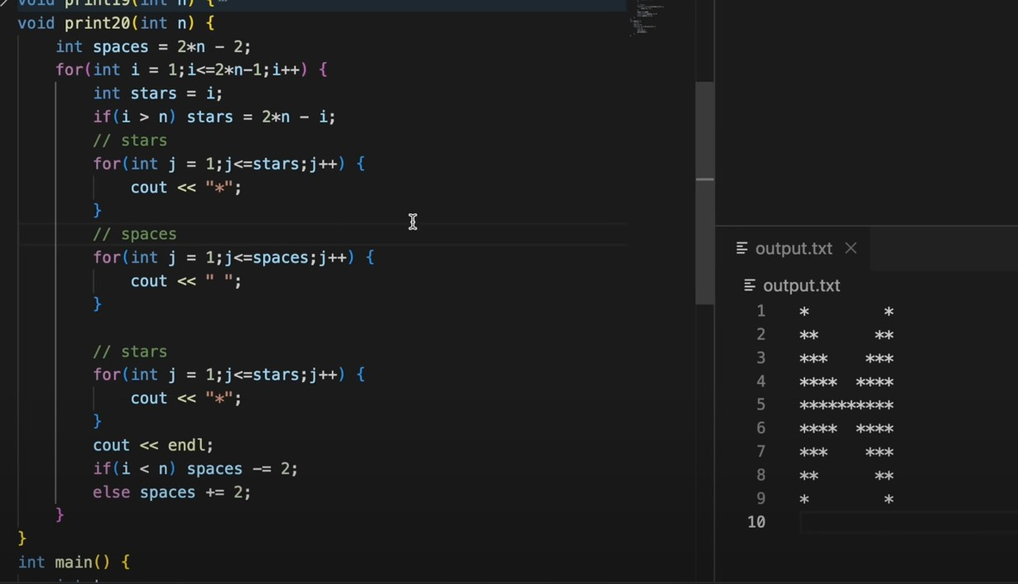

**PATTERN 21**

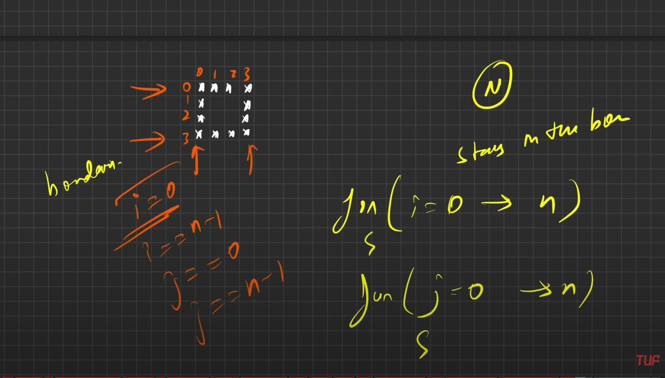

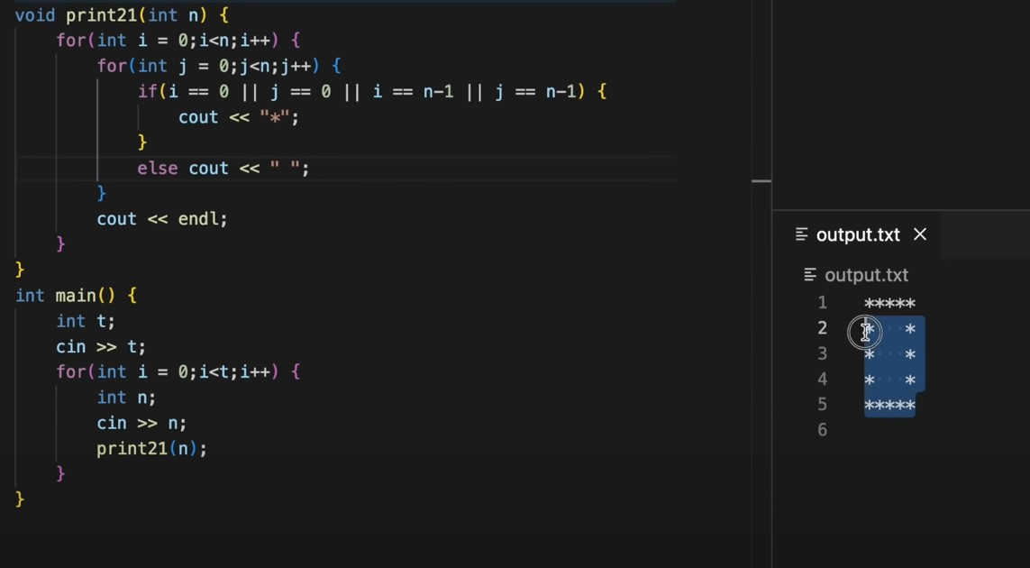

**PATTERN 22**

